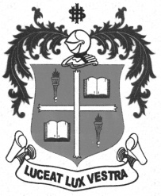
LOYOLA COLLEGE (AUTONOMOUS), CHENNAI – 600 034
M.A. DEGREE EXAMINATION - TAMIL LITERATURE
SECOND SEMESTER – APRIL 2012

TL 2802 - HISTORY OF TAMILNADU & CULTURE-II

Date : 21-04-2012 Dept. No. Max. : 100 Marks

Time : 9:00 - 12:00



 x=
- 
- 
- 
- 
- 

- 



 x=
- 
- 
- 
- 
- 
- 



 x=
- 
- 
- 

- 
**********

